WUSCEL-related homeobox gene family phylogeny

in crop species

**Minjeong Kang**

1. Introduction

The cell fate during plant cell development is specified by various genes and its regulation. The WUSCHEL-RELATED HOMEOBOX (WOX) gene family involve in the important developmental processes, such as stem-cell maintenance and organ formation in shoot apical meristem (Alvarez et al., 2018). The WOX genes play important role in *Arabidopsis* organizing center (OC). A regulatory loop between CLAVATA (CLV) and WUSCHEL involves the maintenance of the shoot apical meristem (Schoof et al., 2000). The WOX gene family is a subgroup of homeodomain (HD), containing transcription factors, which has 60 amino acid residues with the helix-loop-helix-turn-helix structure (Zhang et al., 2010). Phylogenetic tree of the WOX proteins is spontaneously divided into three clades: the WUS clade, the ancient clade which represents the earliest diverging WOX genes, and the intermediate clade which is interspersed between two clades (Graaff et al., 2009).

Maximum likelihood (ML) is optimality criterion to select evolutionary trees. The likelihood (*L*) is defined as the probability of the data (*D*) given a model of evolution (*M*) and other parameters (*p*), such as model parameters and a tree topology (Posada et al., 2004).

*L* = P ( *D* | *M, p* )

The ML requires at least approximately correct model assumptions, such as GTR, the generalized time-reversible model (Tavaré, 1896), to derive a result. When the model is not enough to describe the evolution of the sequence, the ML may not guarantee good results (Allman and Rhodes, 2005).

In the present study, 44 WOX members of turnip, tomato, potato, rice, maize, sorghum and *Arabidopsis* were analyzed by maximum likelihood. The phylogeny tree is grouped into three clades and two ectopic OsWOXs were identified.

1. Materials and Methods

*Search of WOX proteins and domain identification*

The sequence used in this paper were obtained from EnsemblPlants (https://plants.ensembl.org) and NCBI (https://www.ncbi.nlm.nih.gov). Total 44 WOX protein sequences from dicots: *Arabidopsis thaliana, Brassica rapa, Solanum lycopersicum,* and *Solanum tuberosum,* and monocots: *Oryza sativa* (japonica group)*, Zea mays, and Sorghum bicolor*. The WOX names used in this paper is based on the description in database and isoforms are marked as a and b (see Supplementary Table 1). In order to examine the sequences, the motif analysis was carried out using MOTIF search (http://www.genome.jp/tools/motif/) and MAST (version 4.12.0) (Bailey and Gribskov, 1998).

*Multiple sequence alignment and Phylogenetic tree construction*

Multiple sequence alignments were conducted by using MAFFT (version 7.245) with auto strategy setting. Maximum likelihood analysis was conducted with the following parameters by RAxML (version 8.2.9): PROTGAMMAAUTO and bootstrap (100 replicates). The Dendroscope software (version 3.5.9) was used to visualize the tree.

1. Results

*Analysis of conserved domains*

The motif discovery of was conducted to identify the conserved homeodomain in WOX family proteins. All protein sequences used for this study showed the characteristic homeodomain of WOX genes which is 60 aa helix-loop-helix-turn-helix structure (Figure 1 and Supplementary Table 2) (Lian et al., 2014).

*Phylogenetic analysis of WOXs*

Phylogenetic analysis was conducted to investigate the divergence of WOXs among crops. Figure 2 shows the ML tree with the bootstrap values. Corresponded with the previous studies (Graaff et al., 2009; Lian et al., 2014), the WOXs were divided into three groups, designated WOX1 – WOX7 and WUS in WUS clade, WOX 8, 9, 11, and 12 in intermediate clade, and WOX 10, 13 and 14 in ancient clade except OsWox7 and OsWox10 (Figure 2 and 3). The bootstrap values in interior edges of WUS clade is relatively lower than other clades. Generally, each monocot and dicots formed subgroups in the clades. This result suggests that WOX gene divergence occurred before the speciation of monocot and eudicot.

1. Discussion

Although most of WOX proteins form clades with its homologs proteins, the OsWox7 and OsWox10 showed ectopic location. Previous research indicates that the WOXs from monocots form 3-5 clades unlike AtWOXs (Nardmann and Werr, 2006). Therefore, it is possible that the differentiation of several WOXs may occurred after speciation of monocot and eudicot.

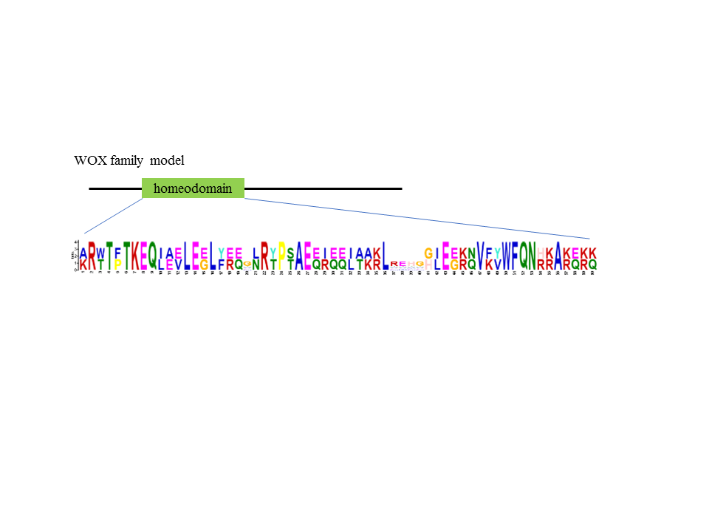

Figure 1. Conserved residues of WOX homeodomain sequence

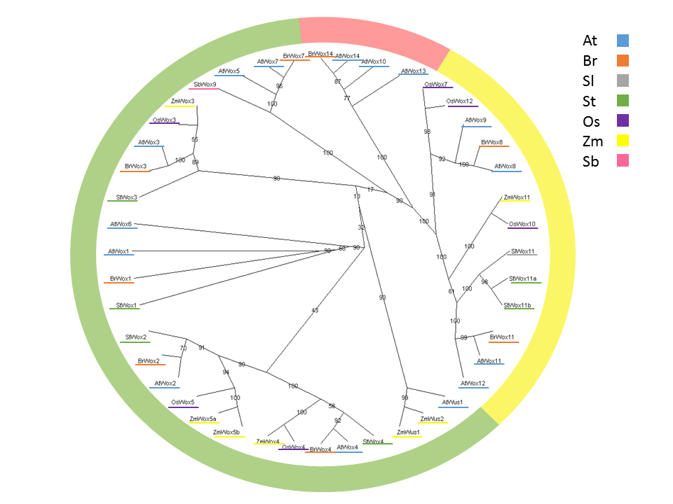

Figure 3. The radial cladogram tree. The color underline represents each crop specie. Outer circle indicates the clade of taxa. The green is the WUS clade, the red is ancient clade, and the yellow is intermediate clade.

**References**

Allman, E.S., and J.A. Rhodes. 2005. Lecture Notes: The Mathematics of Phylogenetics. : 126 Available at https://jarhodesuaf.github.io/PhyloBook.pdf (verified 12 April 2018).

Alvarez, J.M., N. Bueno, R.A. Cañas, C. Avila, F.M. Cánovas, and R.J. Ordás. 2018. Analysis of the WUSCHEL-RELATED HOMEOBOX gene family in Pinus pinaster: New insights into the gene family evolution. Plant Physiol. Biochem. 123(September 2017): 304–318.

Bailey, L.T., and M. Gribskov. 1998. Combining evidence using p-values: application to sequence homology searches. Bioinformatics 14(1): 48–54.

Graaff, E., T. Laux, and S.A. Rensing. 2009. The WUS homeobox-containing (WOX) protein family. Genome Biol. 10(12): 248.

Lian, G., Z. Ding, Q. Wang, D. Zhang, and J. Xu. 2014. Origins and evolution of WUSCHEL-related homeobox protein family in plant kingdom. Sci. World J. 2014(2009): 1–13.

Nardmann, J., and W. Werr. 2006. The Shoot Stem Cell Niche in Angiosperms: Expression Patterns of WUS Orthologues in Rice and Maize Imply Major Modifications in the Course of Mono- and Dicot Evolution. Mol. Biol. Evol. 23(12): 2492–2504.

Posada, D., T.R. Buckley, and J. Thorne. 2004. Model Selection and Model Averaging in Phylogenetics: Advantages of Akaike Information Criterion and Bayesian Approaches Over Likelihood Ratio Tests (J Thorne, Ed.). Syst. Biol. 53(5): 793–808.

Schoof, H., M. Lenhard, A. Haecker, K.F.. Mayer, G. Jürgens, and T. Laux. 2000. The Stem Cell Population of Arabidopsis Shoot Meristems Is Maintained by a Regulatory Loop between the CLAVATA and WUSCHEL Genes. Cell 100(6): 635–644.

Tavaré, S. 1896. Some Probabilistic and Statistical Problems in the Analysis of DNA Sequences. Am. Math. Soc. 17: 57–86.

Zhang, X., J. Zong, J. Liu, J. Yin, and D. Zhang. 2010. Genome-wide analysis of WOX gene family in rice, sorghum, maize, arabidopsis and poplar. J. Integr. Plant Biol. 52(11): 1016–1026.

Supplementary Table 1. Accession numbers for all protein used in phylogenetic analysis

|  |  |
| --- | --- |
| Name | Accession number |
| AtWus1 | NP_565429 |
| AtWox1 | AAP37133 |
| AtWox2 | AAP37131 |
| AtWox3 | AAP37135 |
| AtWox4 | AAP37134 |
| AtWox5 | AAP37136 |
| AtWox6 | AAP37137 |
| AtWox7 | NP_196196 |
| AtWox8 | AAP37138 |
| AtWox9 | AAP37139 |
| AtWox10 | NP_173494 |
| AtWox11 | NP_001118563 |
| AtWox12 | AAP37141 |
| AtWox13 | AAP37142 |
| AtWox14 | NP_173493 |
| BrWox1 | XP_009135563.1 |
| BrWox2 | XP_009120441.1 |
| BrWox3 | XP_009140922.1 |
| BrWox4 | XP_009145045.1 |
| BrWox7 | XP_009122174.1 |
| BrWox8 | XP_009128835.1 |
| BrWox11 | XP_009130381.1 |
| BrWox14 | XP_009149550.1 |
| OsWox3 | XM_015764119.1 |
| OsWox4 | XP_015635367.1 |
| OsWox5 | Q8LR86 |
| OsWox7 | Os01t0667400-01 |
| OsWox10 | XM_015794156.1 |
| OsWox12 | Os05t0564500-00 |
| SbWox9 | XM_002458736 |
| SlWox11 | XP_010322493.1 |
| StWox1 | XP_006341531.1 |
| StWox2 | XP_006350912.1 |
| StWox3 | PGSC0003DMG400025358 |
| StWox4 | XP_006354857.1 |
| StWox11a | XP_015164268.1 |
| StWox11b | XP_006347326.1 |
| ZmWus1 | CAJ84136 |
| ZmWus2 | NP_001105961 |
| ZmWox3 | CAM32346 |
| ZmWox4 | CAM32347 |
| ZmWox5a | CAM32348 |
| ZmWox5b | NP_001306687 |
| ZmWox11 | NP_001147238 |

Supplementary Table 2. Result of Motifinder

|  |  |  |
| --- | --- | --- |
| Query | Pfam | Description |
| AtWox1 | Homeobox | PF00046, Homeobox domain |
| AtWox2 | Homeobox | PF00046, Homeobox domain |
| AtWox3 | Homeobox | PF00046, Homeobox domain |
| AtWox4 | Homeobox | PF00046, Homeobox domain |
| AtWox5 | Homeobox | PF00046, Homeobox domain |
| AtWox6 | Homeobox | PF00046, Homeobox domain |
| AtWox7 | Homeobox | PF00046, Homeobox domain |
| AtWox8 | Homeobox | PF00046, Homeobox domain |
| AtWox9 | Homeobox | PF00046, Homeobox domain |
| AtWox10 | Homeobox | PF00046, Homeobox domain |
| AtWox11 | Homeobox | PF00046, Homeobox domain |
| AtWox12 | Homeobox | PF00046, Homeobox domain |
| AtWox13 | Homeobox | PF00046, Homeobox domain |
| AtWox14 | Homeobox | PF00046, Homeobox domain |
| AtWus1 | Homeobox | PF00046, Homeobox domain |
| ZmWus1 | Homeobox | PF00046, Homeobox domain |
| ZmWus2 | Homeobox | PF00046, Homeobox domain |
| ZmWox5a | Homeobox | PF00046, Homeobox domain |
| ZmWox5b | Homeobox | PF00046, Homeobox domain |
| ZmWox3 | Homeobox | PF00046, Homeobox domain |
| ZmWox4 | Homeobox | PF00046, Homeobox domain |
| ZmWox11 | Homeobox | PF00046, Homeobox domain |
| SbWox9 | Homeobox | PF00046, Homeobox domain |
| SlWox11 | Homeobox | PF00046, Homeobox domain |
| StWox4 | Homeobox | PF00046, Homeobox domain |
| StWox2 | Homeobox | PF00046, Homeobox domain |
| StWox1 | Homeobox | PF00046, Homeobox domain |
| StWox11a | Homeobox | PF00046, Homeobox domain |
| StWox11b | Homeobox | PF00046, Homeobox domain |
| StWox3 | Homeobox | PF00046, Homeobox domain |
| OsWox7 | Homeobox | PF00046, Homeobox domain |
| OsWox12 | Homeobox | PF00046, Homeobox domain |
| OsWox4 | Homeobox | PF00046, Homeobox domain |
| OsWox5 | Homeobox | PF00046, Homeobox domain |
| OsWox10 | Homeobox | PF00046, Homeobox domain |
| OsWox3 | Homeobox | PF00046, Homeobox domain |
| BrWox8 | Homeobox | PF00046, Homeobox domain |
| BrWox14 | Homeobox | PF00046, Homeobox domain |
| BrWox2 | Homeobox | PF00046, Homeobox domain |
| BrWox7 | Homeobox | PF00046, Homeobox domain |
| BrWox11 | Homeobox | PF00046, Homeobox domain |
| BrWox4 | Homeobox | PF00046, Homeobox domain |
| BrWox1 | Homeobox | PF00046, Homeobox domain |
| BrWox3 | Homeobox | PF00046, Homeobox domain |